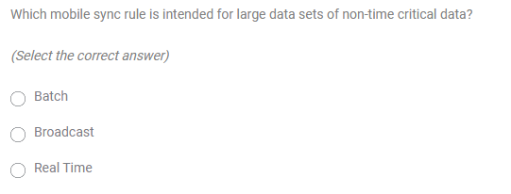

Answer: 1

Answer: 1

Answer: 2

Answer: 1

Answer:

STUDIO, NAMED, or MOBILE

Answer: 3

Answer: 2

Answer: 1

Answer: 1

Answer: 1